CMCFN Affiliate Report 9/23/17

The Far North Affiliate will have our annual conference on Saturday, Oct. 14, 2017.
Website cmcfn.com has registration ready to go, and splash page updated. Now we are using our lists of “year leading up to,” Week before,” and “day of” files to keep on track. This is the transition year from Beth B. as president to Gwen Neu pres-elect. Gwen will be pres. in 2018. We need to find a Pres-elect for her.

Prep Meeting 9/9/17
- Attending: Beth, Gloria, Gwen, Cathy, Bill, Ali, Lynn, MaryAnn
- Treasurer’s report: $8000- up from $3000 4 years ago.
- Team #’s and $ are both on the rise.
- Reviewed Meeting agenda
- Massaged presenter matrix

**Most items have been copied to agenda** (see pasted below)

Things to do:
- Beth to email Alicia and Annika to prep a TK-2 breakout on Critter Legs from Marcy Cook - Will order a booklet for each teacher and give out at the session. Moved to Ursula F in 1st grade to pilot
- Beth and Bill to meet to streamline registration process-one general reg. Button on cmcfn.com and then a simple Google form to send out upon request for group registration - last year’s registration was a problem when the Weebly store detached each registrant from his or her school or grant. Billing was slow and tedious as we sorted out 120+ teachers.
- Beth ordering folders and pencils and sending to Lisa-done.
- Gwen to send MaryAnn equipment need for keynote
- Need to create and get out flyers-done and will do again. Ryan K at HCOE stuffed boxes.
- Gwen to email/call Harold to see what workshops he can do and if he’s bringing a team-done
- -using classroom assessment to prepare students for SBAC
- MaryAnn to contact Mike Butler
- MaryAnn getting items for folders-confirmed

Our timeline is maturing and the basis of how we approach our annual conference:
CMCFN Conference Time-Line Updated 8/05/17

January

● Action plan
● Pay grants
● Attend CMCN affiliates workshop (Beth,Cathy and MaryAnn)-update CMCFN
February
● Committee members each have liaison schools and districts to get admin/LCAP to promote attendance to staffs
● Meet with HSU (Dale Oliver)/HCOE to coordinate conference
● Set a date for conference Oct 14, 2017
● Set Facility-Sequoia
● Begin researching keynotes/Cathy Humphries/Andrew Stadel/Chris Shore https://mathprojects.com/about/
● Email past speakers
● Keep webpage current ~ Cathy (photos)
● Mission Statement on Webpage at the top
March
● Begin working on speakers
● Speaker proposal form on website
● Keep webpage current ~ Cathy
● Create/Maintain email list for math teachers-Beth
● Lisa- Call school secretaries to send survey to teachers at the school.
● Find the HCOE Math coordinator to support us with county communication. Ryan and Rosie)
● Beth/ECS & Sup. DelNorte Mary Ann/Northern Hum Gwen/Charters Cathy Sinnen FUHSD
● Ken Pinkerton - Advertising and getting students involved
● Executive Sect-(Gretchen)get members of CMCN in our Counties Humboldt/DelNorte
April
● Continue working on speakers
● Keep webpage current ~ (useful links to CCSS)
● Get “save the date” info out to teachers-email with survey: “what do you and your math colleagues need?”
● Submit conference description to HCOE/DelNorte/Trinity professional development catalog
● Connect with RCPLI & ECS Arts Integration team to serve their attendees.
● Ali is the BAGEL CZAR

May

● Submit conference description to Communicator to:
Janet Trentacosta
cmc-communicator@sbcglobal.net
● Beth request HCOE facility
● Post registration form to website
● Continue working on speakers- especially K-2!
● CMCFN meeting to finalize all conference committees
● DelNorte: presenters/partner with CMCFN to bring keynoter
● Beth get scholarship info from County Offices and HSU
June
● Revise Grant application focus/google form
● Continue work on matrix-recruit presenters
July
● Website-get e-registration up and running
August
● Work on program draft
● Continue to work on speakers
● Email committee members to get updates on progress/set meeting date
● CMCFN meeting to get update from all committees (first week of school) at Fiesta Grill
● Email registration forms to CMCFN list
● ORDER FOLDERS
● Draft of conference program online
● Email draft matrix and updates to Cathy to set up session evaluations
● Folders find coolio paper puzzles to copy and put into folders Lisa and MaryAnn
● Send registration forms to school sites via HCOE. ( HCOE)
Include forms, posters, cover letter to principals (Include 2 for 1 price)
● Press releases (conference description) to Del Norte COE, Mendocino COE, Trinity. Follow up call to these COEs. Local radio stations and newspapers Lisa Klar/Beth do TV
● Packets (see Folders)
● Revise mini-grants-focused on teacher collaboration/peer coaching-update application on website
● Facility/McMiddle (long story!)

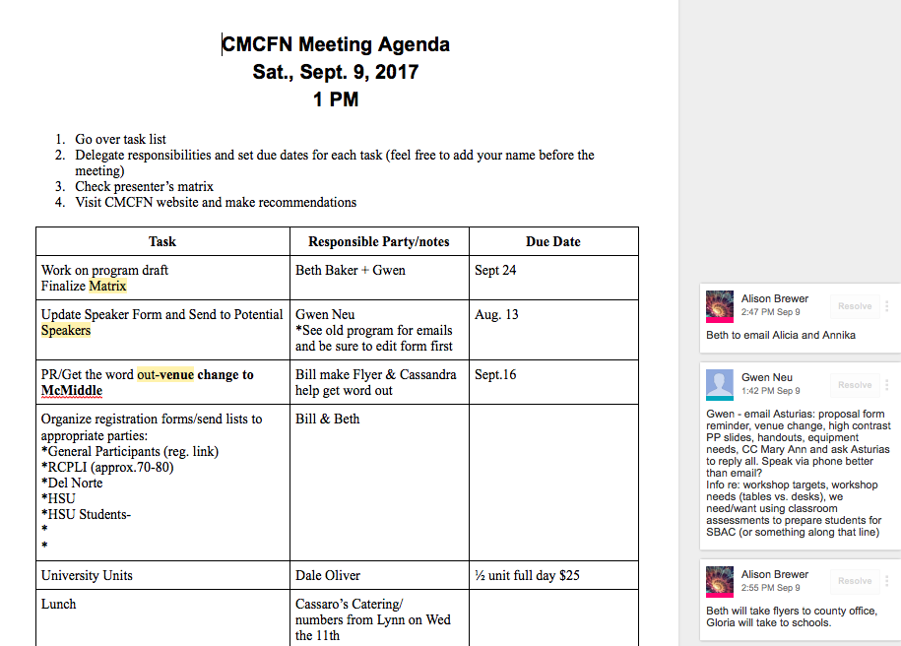
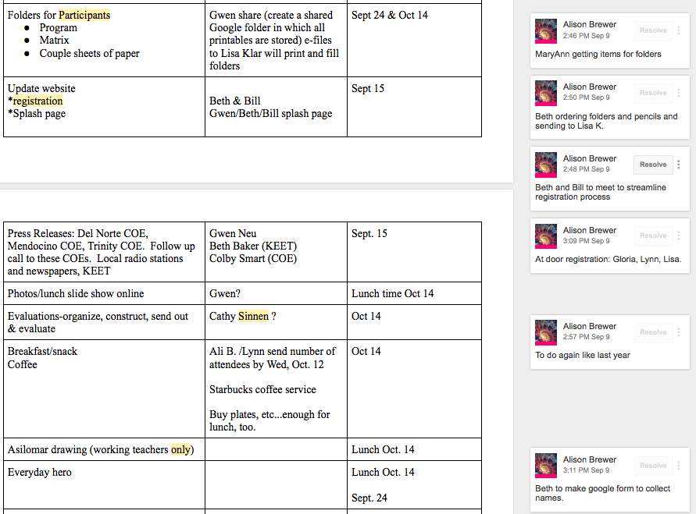
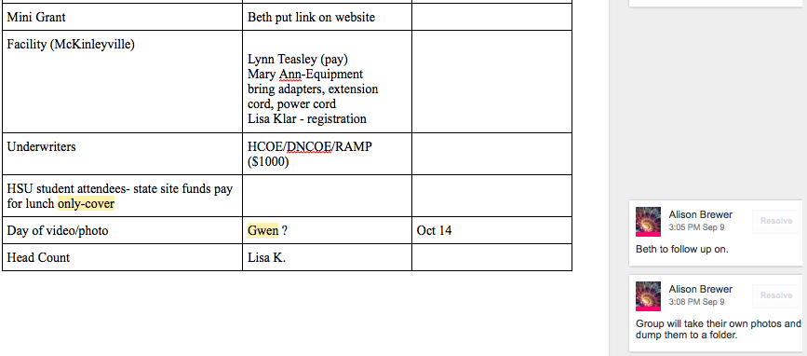

Other Business:
CMCFN sponsors the Humboldt Math Festival with an annual grant.

Asilomar:

We will be raffling 2 $550 scholarships to Asilomar at the conf. This year two working teachers will come with the team to the CMCN conf. Last year we did not limit who could enter and a college Junior won, attended and then decided not to become a teacher. Lesson learned.

